

Dates to Remember:

Aug. 30th- 2:00pm dismissal

2nd- No school

13th- 12:30pm dismissal

18th- Midterm grades sent home

19th- Ag in the Class

26th- Super Hero Math assembly

28th- Appleknocker, at FES

The first few weeks of school have been going great! I am very pleased with how well students are adjusting to our 4th grade routine... we have very busy days! Please let me know if you have any questions. I am looking forward to a great year!

\*This month in reading we will be working on predicting, main idea and details, character traits, setting, and plot.

\*We are working hard on our AR goals!

\*In math we will be working on multiplication facts and multiplying by a 1-digit number.

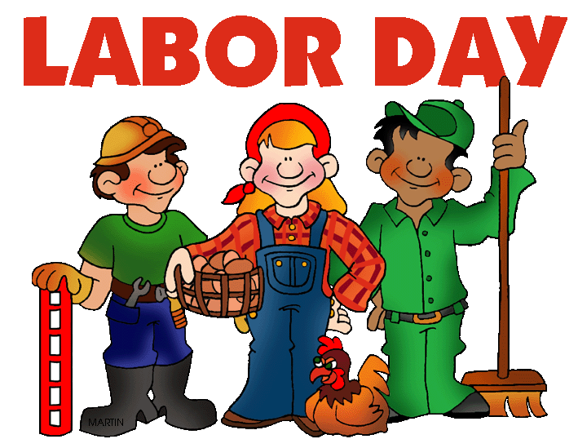

Box Tops

We are on the hunt for Box Tops! Please start your collection and send to school. We greatly appreciate it! ☺



Schedule Reminder:

Monday- P.E.

Tuesday- P.E.

Wednesday- Art

Thursday- P.E.

Friday- Music

Lunch- 11:50am-12:30pm

Recess 2:15pm-2:30pm

\* Please remember to empty your child’s folder every night and sign their agenda book. Thanks again for all your

help at home!



Don’t forget...

Ms. Ferguson has started band lessons! It is important for your child to remember what day their lesson is on. Any questions regarding band, please contact Ms. Ferguson

@ 662-2014.

Thanks for all you do,

Mrs. Hilmes ☺